CONFIDENTIAL CS/OCT 2026/MAT133

UNIVERSITI TEKNOLOGI MARA FINAL EXAMINATION

COURSE
COURSE CODE
EXAMINATION TIME
PRE CALCULUS
MAT133 OCTOBER 2026
2 HOURS

INSTRUCTIONS TO CANDIDATES

- This question paper consists of 5 questions.

- Answer ALL questions in the Answer Booklet. Start each answer on a new page.

- Do not bring any material into the examination room unless permission is given by the invigilator .
- Please check to make sure that this examination pack consists of: i) the Question Paper
  - a one - page Append ix 1
  - an Answer Booklet - provided by the Faculty
  - a graph paper - provided by the Faculty

- Answer ALL questions in English.

/

DO NOT TURN THIS PAGE UNTIL YOU ARE TOLD TO DO SO

This examination paper consists of 7 printed pages

QUESTION 1
a) Solve the compound inequality -3 < 3x - 1 < 2. Express the answer in interval notation.
(4 marks)
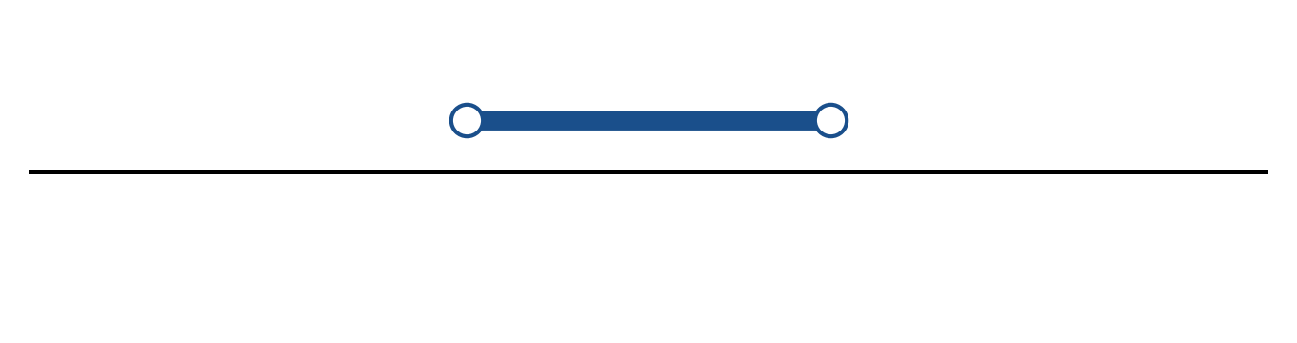
Figure: solution on a number line.
b) Solve the inequality |2 - 5x| > 7. Express the answer in interval notation and on a number line.
(5 marks)
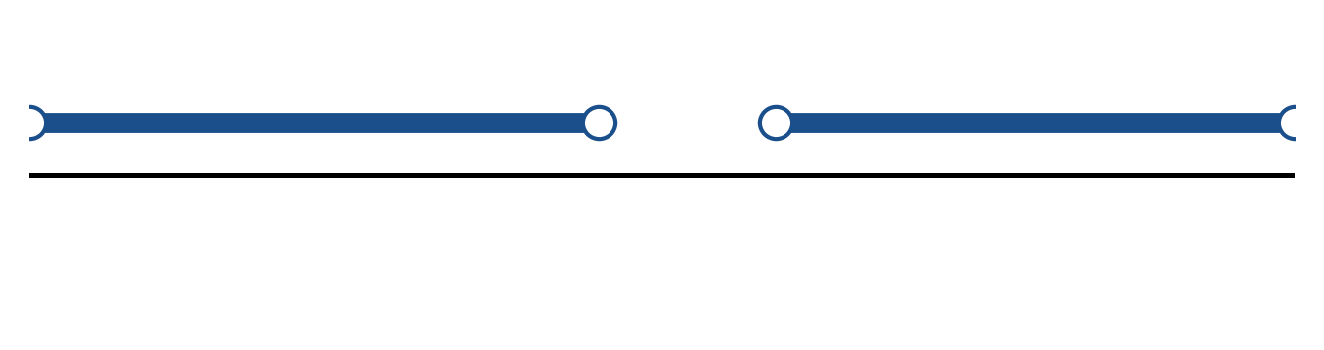
Figure: solution on a number line.
c) Sketch y = -3|x + 4| - 3. State the vertex, the y-intercept and any x-intercepts.
(5 marks)
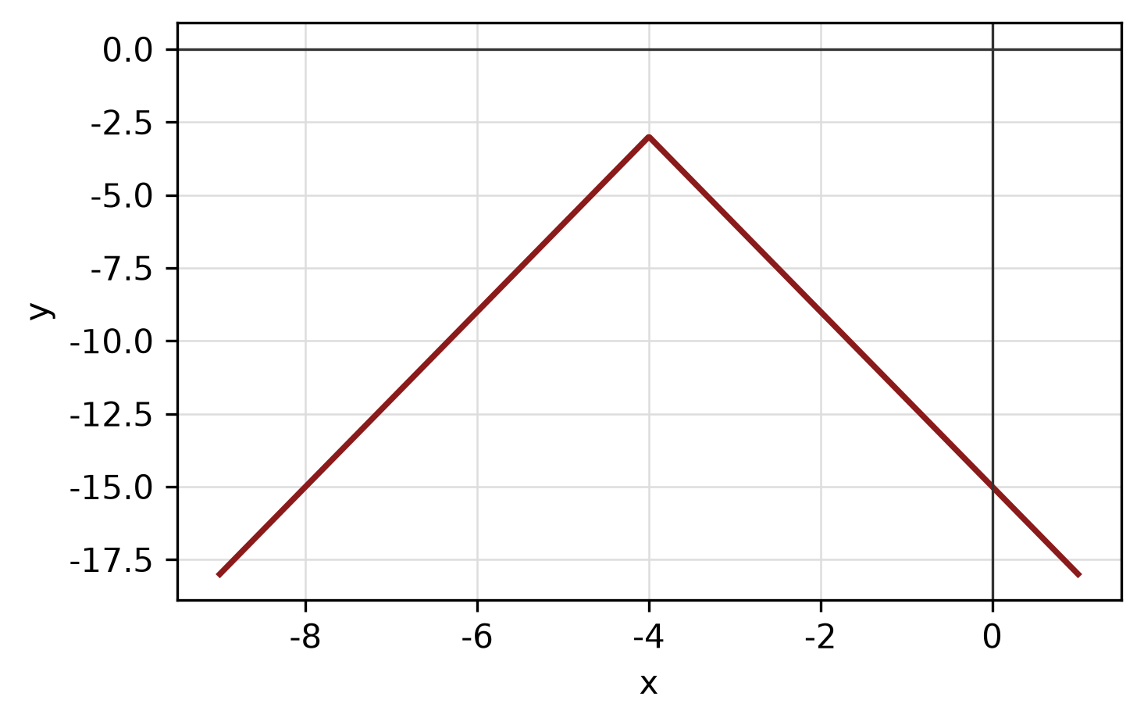
Figure: absolute-value graph.
QUESTION 2
a) Given f(x) = (3 - 5x)/(x - 4) and g(x) = √(3x - 5), state the domain of each function.
(4 marks)
b) Apply graph-transformation techniques to sketch y = -2(x - 4)² + 5. State the vertex and the y-intercept.
(5 marks)
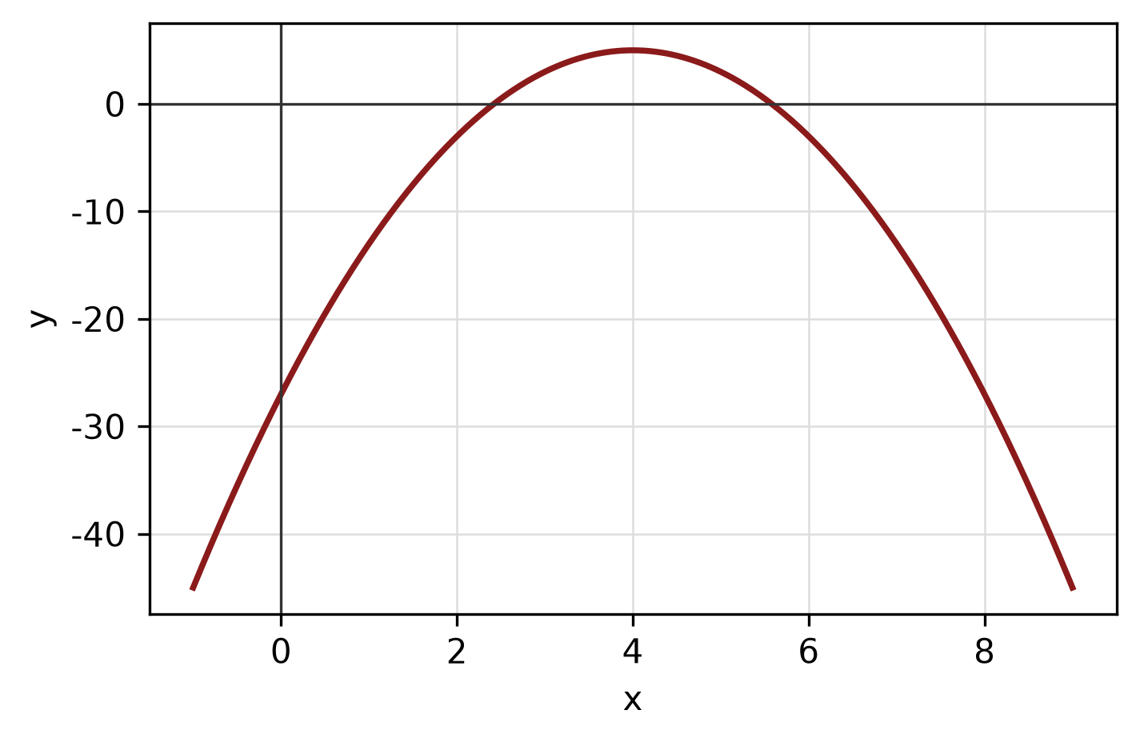
Figure: transformed graph.
c) Write the equation of the circle with centre (4, 1) and radius 2. Hence write its general equation and sketch the circle.
(5 marks)
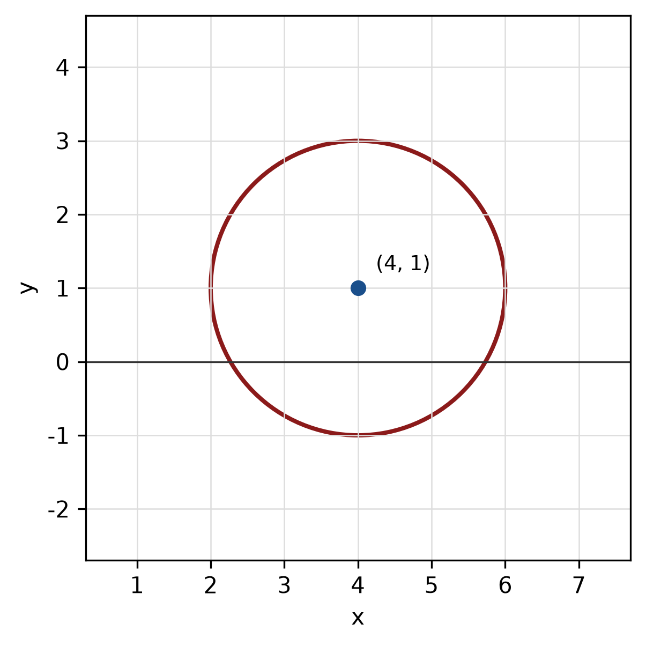
Figure: circle.
QUESTION 3
a) Given z₁ = 2 + 4i and z₂ = 3 + 2i, express z₁/z₂ in the form a + bi.
(5 marks)
b) Find the modulus and argument of z = -5 + 12i. Give the argument in degrees correct to one decimal place.
(5 marks)
c) Factorise f(x) = x^3 - 2x² - 9x + 18 completely.
(5 marks)
QUESTION 4
a) Solve the system of equations simultaneously:
-3x + 3y + z = -14
2x + 2y - 3z = 2
2x + 3y + 3z = -13
(5 marks)
b) Graph the system of inequalities below and shade the feasible region. State the vertices of the region.
x ≥ 0, y ≥ 0, 1x + 3y ≤ 6.
(5 marks)
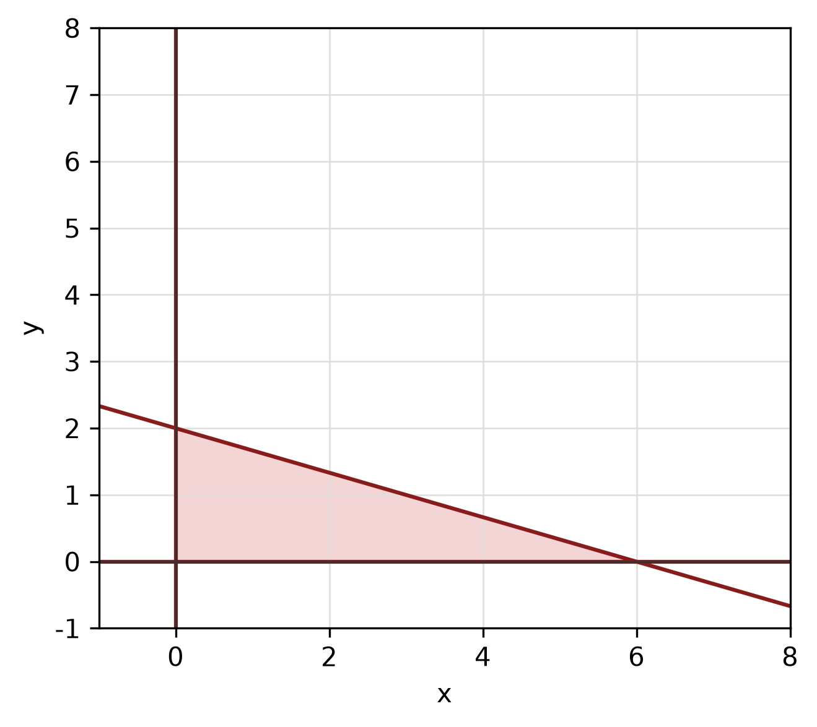
Figure: feasible region.
c) Find the equation of the line with x-intercept 4 and y-intercept -2.
(4 marks)
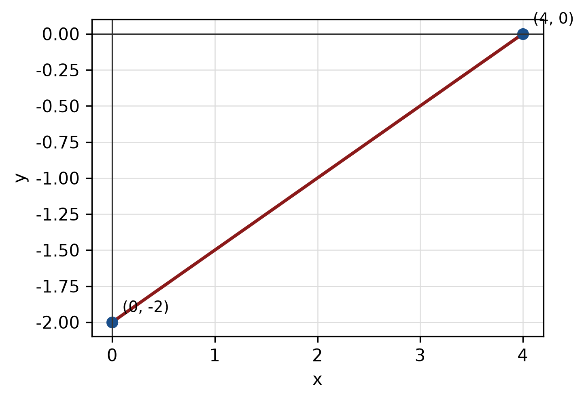
Figure: line and intercepts.
QUESTION 5
a) For y = 2 sin(1x + 30) + 2, state the amplitude, period and phase shift, then sketch the graph for -180° ≤ x ≤ 180°.
(5 marks)
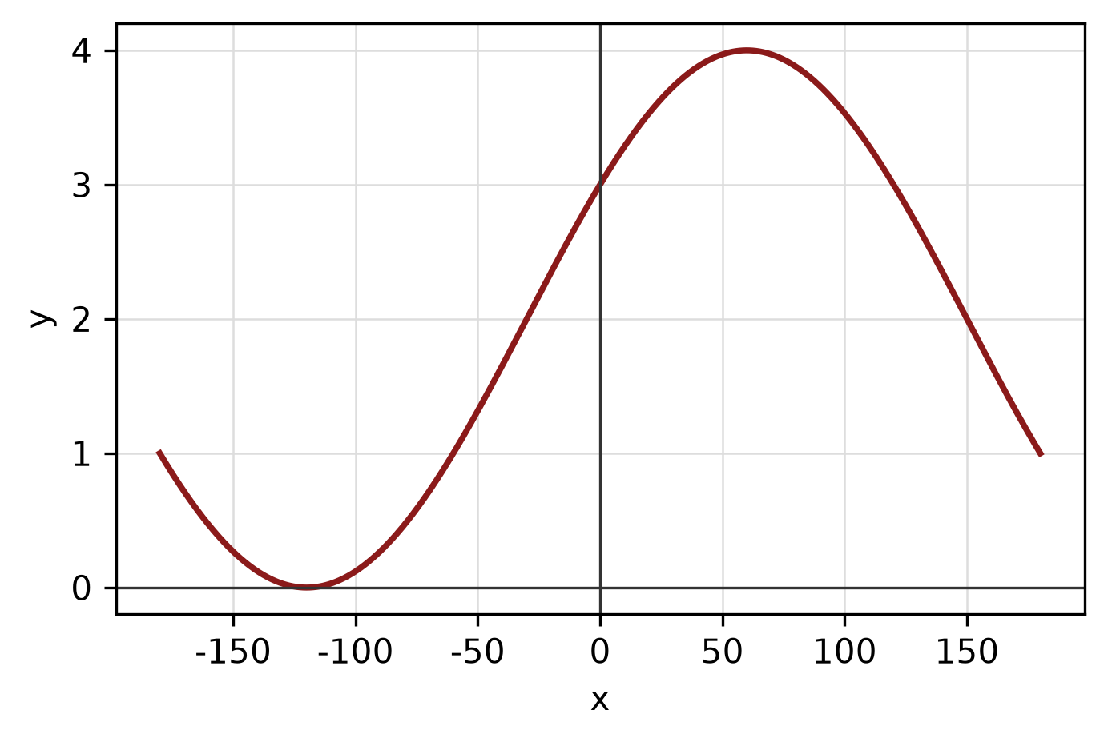
Figure: trigonometric graph.
b) A circle has radius 6 cm. Find the length of the arc subtended by a central angle of 30°.
(4 marks)
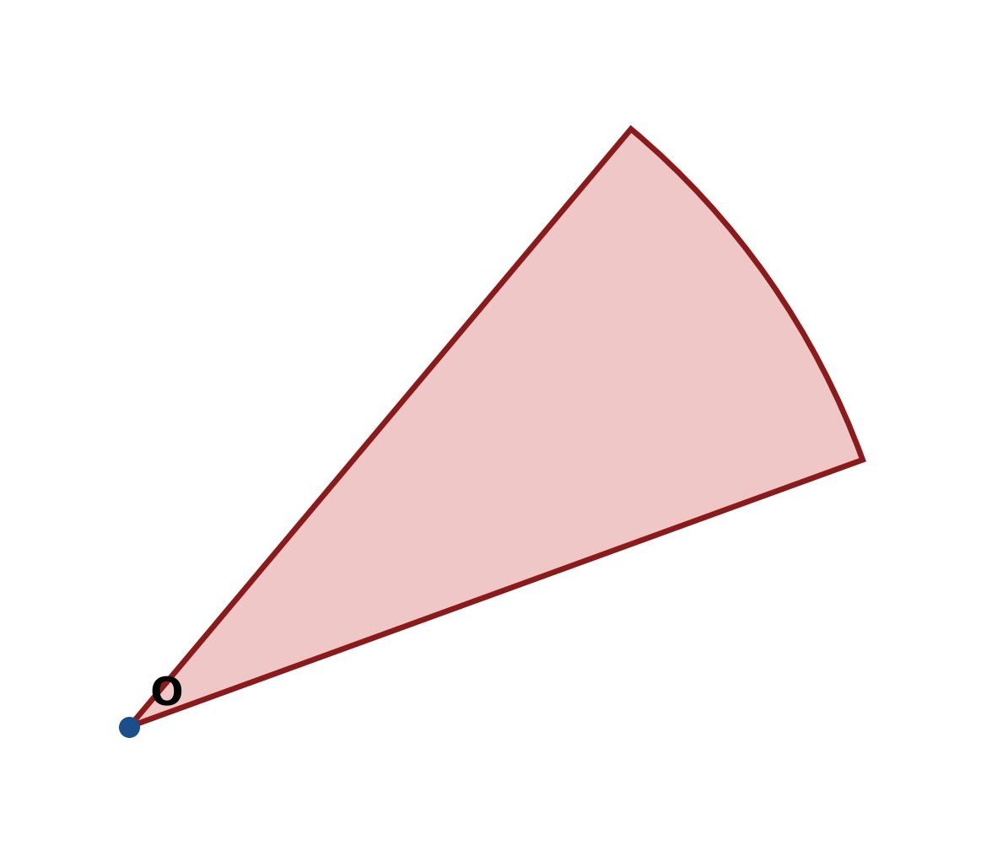
Figure: arc and sector.
c) In triangle ABC, b = 9 cm, c = 12 cm and A = 120°. Use the cosine rule to find a.
(4 marks)
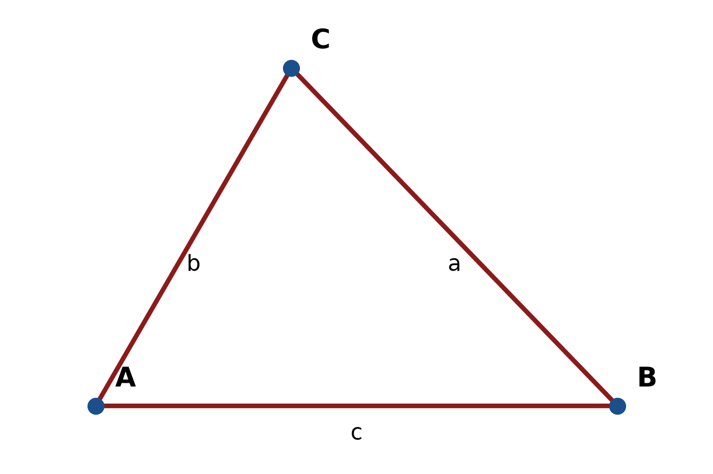
Figure: triangle ABC.
END OF QUESTION PAPER

APPENDIX 1
Formula sheet (as supplied with the paper).
sin² A + cos² A = 1 | tan² A + 1 = sec² A
sin(A + B) = sin A cos B + cos A sin B | tan 2A = 2 tan A / (1 − tan² A)
cos(A + B) = cos A cos B − sin A sin B | Arc length, s = rθ
tan(A − B) = (tan A − tan B) / (1 + tan A tan B) | Area of sector = ½r²θ
cos 2A = cos² A − sin² A | a / sin A = b / sin B = c / sin C
cos 2A = 1 − 2sin² A = 2cos² A − 1 | a² = b² + c² − 2bc cos A
sin 2A = 2 sin A cos A | Area of triangle = ½ab sin C

